Command Parameters
When the report definition’s SQL source is a table value function In the Command window do the following:

Define the table value function’s arguments as Parameters in the Command window. Use the same naming convention we use for database columns, such as:
ar_document, gl_date, etc.

It is a good idea to specify a Default Value since you are prompted to provide one for each parameter when you edit the Command.

You only define parameters in the Command window that are needed in the Command’s Select statement.

Parameters only used on the Selection window are NOT defined in the Command Window.

You do not return the Command Parameters in the Select statement as their values are available in the Report Definition window:

The parameters defined in the Command window appear in the Parameters section of the Report Definition. There is no need to edit/modify those.

Next enter the SQL Select command and insert the defined parameters in the SQL command.

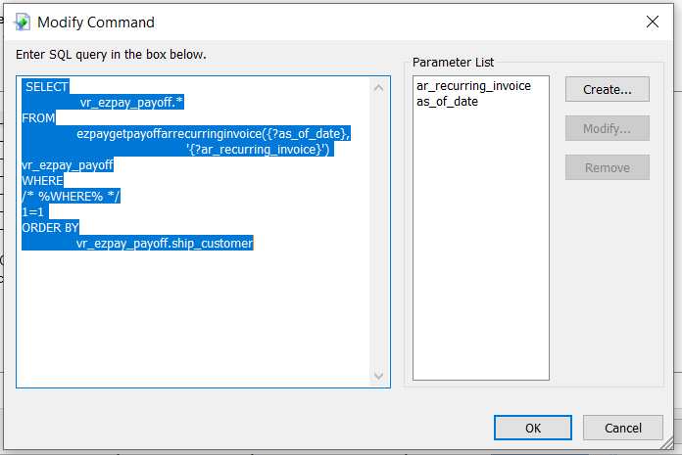

Note: As Parameters are created, they appear in the Parameter List panel in alphabetical order. You cannot change their order here. You can change the order in the Report Definition Parameter list later.

Note: When you insert a Date or Number parameter in the SQL statement you do not enclose it in single quotes. You DO enclose string parameters in single quotes. In the above example the ar_recurring_invoice parameter is enclosed in single quotes, while the as_of_date parameter is not.

Next add the base WHERE clause required for the subsequent Selection window parameters to be added by EmpowerWin at runtime in the format:

WHERE
/* %WHERE% */
1=1

Next add an ORDER BY clause to the Select statement if you want to.

Report Definition Parameters

In the Crystal Reports Report Definition IDE you add Parameters needed for the Selection window that were NOT included in the Command SQL statement.

Use the standard column naming convention such as ar_document, document_type.

If you want them to be appended to the WHERE clause then add the prefix:
Command.<view name> to the column name. For example, naming a Parameter:

Command.vr_ar_recurring_invoice_items. ar_recurring_invoice

The report uses a Command
The result set is named vr_ar_recurring_invoice_items
The Parameter name ar_recurring_invoice

If they are parameters that are NOT included in the WHERE clause do not specify the prefix. This is used for parameters that capture data used in formulas in the report but are not present in the database and therefore not used in the WHERE clause or result set.

